# Student App in Python and HTML/Jquery using RESTful api

## -Arti Sinha

# Introduction

This is demo student application. It has two parts.

* REST API(Python)
* Frontend(Html, jquery)

# a REST API

The REST API includes get, post, put, delete .

|  |  |  |  |  |  |
| --- | --- | --- | --- | --- | --- |
| URL | Method | Body | Response | Response Status | Contents |
| v1/students | get |  | NA | 200 |  |
| v1/student | post | {  "name":"Navin Sinha",  "age":1,  "major":"play",  "sport":"game",  "rank":5  } | {"success": true} | 201 |  |
| v1/student/<string:id> | put |  | NA | 200 |  |
| V1/student/<string:id> | delete |  |  | 200 |  |

# b Frontend

A simple HTML , Jquery ,Bootstrap application.

# Prerequest

Technology used:

Python,mysql,html,jquey

# Installation Steps:

## 3.1 Installing python:

1.Download Python from the url: <https://www.python.org/downloads/>

2.After downloading install the python by following the steps to install.

3.After the installation of python ,plugin the pydev in eclipse

4.Open Eclipse.

5.Go to “help”.->”Install new software”.

6. “Go to "<http://www.pydev.org/updates>" and press Enter.

7.Select PyDev.

8.Click Next and follow the instructions.

9.Restart Eclipse

10.For reference link used: https://www.wikihow.com/Install-Pydev-on-Eclipse

## 3.2. Adding pip

Pip is package management system used to install and manage package written in Python.

Link to add pip:

<https://github.com/BurntSushi/nfldb/wiki/Python-&-pip-Windows-installation>

## 3.3.Installing flask

Flask is micro web framework used in python.

1. Open cmd and type ”pip install flask”

2. Done with the installation ,then move towards other step.

## 3.4.Installing mysql connection

**MySQL** Enterprise Edition. The most comprehensive set of advanced features, management tools and technical support to achieve the highest levels of **MySQL** scalability, security, reliability, and uptime.

To install the mysql ,type “pip install mysql” in the cmd, which connect the databse with api.

## 3.5.Installing CORS

Cross-Origin Resource Sharing ([CORS](https://developer.mozilla.org/en-US/docs/Glossary/CORS)) is a mechanism that uses additional [HTTP](https://developer.mozilla.org/en-US/docs/Glossary/HTTP) headers to let a [user agent](https://developer.mozilla.org/en-US/docs/Glossary/user_agent) gain permission to access selected resources from a server on a different origin (domain) than the site currently in use. A user agent makes a **cross-origin HTTP request**when it requests a resource from a different domain, protocol, or port than the one from which the current document originated.

# How to start application

4.1.Start mysql in xampp.

4.2.Start the server.

4.3. Open the index.html file from the given folder in Google Chrome.The url created on the first page is index.html

That page will show index or first page, which includes getting the students, adding a student, edit a student as well as deleting a student.

# Running Application

* Start mysql server
* Run Python (student_flask.py) . You can use Eclipse to start too.
* Open index.html in browser, preferably Chrome.
* Following page will be displayed

Add a student

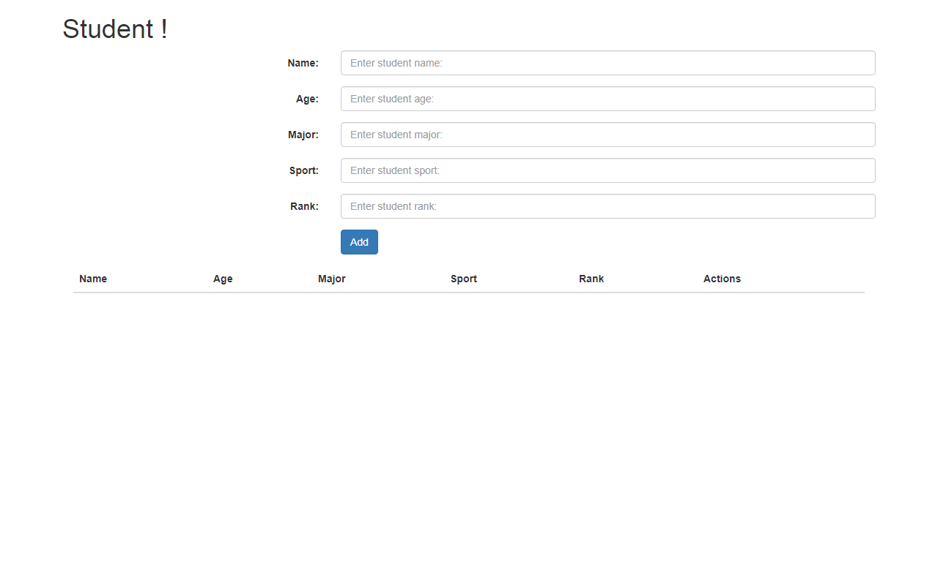

* Enter Student delete and press Add button. This will trigger a POST request. Add button calls a javascript function addStudent which is in scripts/script.js . It will start an ajax request to python server. Python code(server) will add an entry in database.
* Once added Page will refresh and new added user will be displayed at page as in figure below.

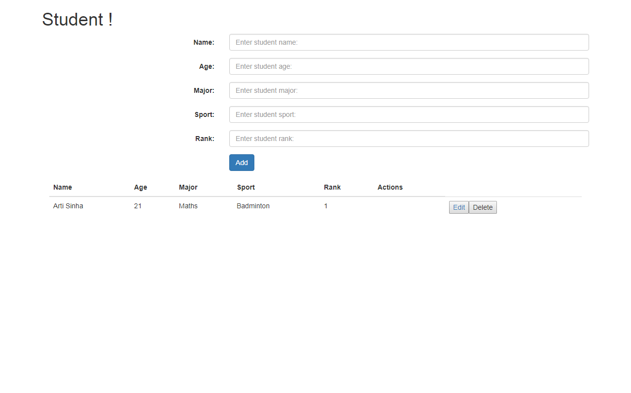

* Once added we have options to edit and delete as shown above.
* Once delete is called deleteStudent(id) function is called . This will again trigger ajax request to server, which will delete the added user.This is done by calling REST url of delete as described above.

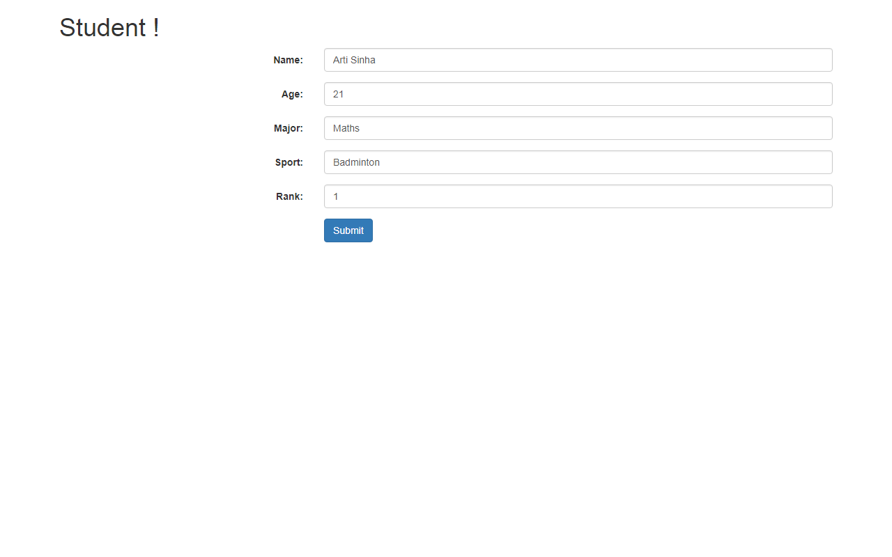

Edit User

* If edit is called another page will open , this will open a new HTML, We are passing id which is unique for each user as request parameter. Once page opens it uses this request parameter to initiate a get request and fetch all the parameter corresponding to user and sets it to form. After that we can edit the details and press submit button to edit. Edit will call the PUT request from its javascript function.